CASE 14: Safaricom: Innovative Telecom Solutions to Empower Kenyans
As the largest mobile provider in Kenya, Safaricom has touched the lives of Kenyans throughout the country, with products and services designed to empower people. Safaricom enjoys a 64.5% market share, 77.5% of voice traffic, and 72.6% of mobile data/internet subscribers.¹ Safaricom facilitates community involvement through various organizations such as the M-PESA foundation, a charitable trust that seeks to advocate programs that improve health, environmental conservation, and education for the financial and social benefit of Kenyans, and the Safaricom Foundation, whose mission is to partner with the community to tackle environmental, economic, and social issues to bring about enduring and progressive change.² Safaricom also serves society by sponsoring athletic events through Safaricom Sevens, the biggest rugby event in Kenya, and by sponsoring the music festival Niko na Safaricom Live, an event featuring local music talent and fostering national pride.³
Safaricom Ltd. was formed as a private limited liability company (LLC) in 1997 and became a publically traded company in 2002. The original company was 60% owned by the Government of Kenya.⁴ In 2000 Vodafone acquired a large stake in the company through Vodafone Kenya Ltd, a locally owned subsidiary.⁵ In 2008 the Government of Kenya sold enough shares to the public to lose its majority interest.⁶ There are a total of 40 billion shares outstanding, which are owned by 698,863 different investors as of March 31, 2013. Of those shareholders, 61.2% own less than 1,000 shares. The top two shareholders, Vodafone Kenya Limited and Permanent Secretary – The Treasury, now own just over 75% of the company. As of October 18, 2013, 52 institutional investors owned only 2.3 million shares, or 5.86% of the remaining shares.⁷
Safaricom has grown through a variety of strategies, including acqusitions. In 2008, Safaricom purchased a majority stake in One Communications Ltd. in order to gain access to its data services.⁸ The company has also made several other small acquisitions to enhance its services and market share.⁹

Operating in Africa
According to KPMG, “Africa is the last great untapped telecommunications market.”¹⁰ Market penetration in Africa is only 47%.¹¹ GDP growth in sub-Saharan Africa remained strong in 2012 at 4.6% despite the global economic slowdown.¹² Kenya is the third largest mobile market in Africa, behind Nigeria and South Africa. Kenya also boasts one of the fasting growing economies in the region. The number of mobile subscribers is expected to grow steadily in the medium to long term with an estimated 13 million new subscribers from 2011 to 2016. There is currently a pricing war going on between the four mobile service providers in Kenya.¹³ A graph of market share for each of these firms is shown in Exhibit 1.

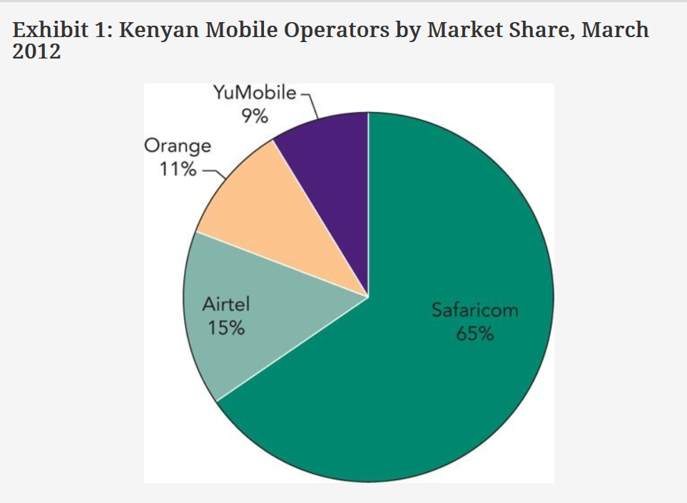Kenya
Kenya is located in East Africa and earned its independence from Great Britain in 1963. Since obtaining independence it has been relatively peaceful. The county is home to over 37 million people and official languages are English and Swahili, although various indigenous languages can be heard throughout Kenya. The currency is the Kenyan shilling (KSh). Its capital is Nairobi, with a population of over 3 million people. There are two heads of state, President Mwai Kibaki and Prime Minister Raila Odinga. In 2010, Kenyan citizens voted to ratify a new constitution, which would decrease the president’s power and establish a bicameral parliament. Kenya has a fairly significant but declining trade deficit. Key trading partners for exports are Uganda, Tanzania, Britain and Germany. Kenya exports a lot of legumes. Key trading partners for imports are Britain, Japan, Germany and the United Arab Emirates. The crime rate in Kenya is quite high, especially crimes of petty theft, armed robbery, burglary and fraud. Corruption is also quite common.¹⁴
Written by Laura Beauchesne, Nick Dorion, Nathaniel Griggs, and Jeffrey S. Harrison at the Robins School of Business, University of Richmond. Copyright © Jeffrey S. Harrison. This case was written for the purpose of classroom discussion. It is not to be duplicated or cited in any form without the copyright holder’s express permission. For permission to reproduce or cite this case, contact Jeff Harrison at RCNcases@richmond.edu. In your message, state your name, affiliation and the intended use of the case. Permission for classroom use will be granted free of charge. Other cases are available at: http://robins.richmond.edu/centers/case-network.html
The country is fortunate to have one of the most diversified economies in sub-Saharan Africa. Its main economic sectors are agriculture, manufacturing and services. Tourism and the export of coffee and tea serve as the two chief means for bringing in foreign funds. In addition to coffee and tea, other agricultural products include wheat, corn, sugarcane, fruit, vegetables, dairy products, beef, pork, poultry and eggs. Nominal gross domestic product (GDP) is 3,036 billion Ksh. growing at a rate of 5.7% annually (real) with inflation at 7.5%. The Kenyan government encourages foreign direct investment, and multinational companies make up a significant portion of Kenya’s industry. The Nairobi Stock Exchange was established in 1954 and is the fourth largest in sub-Saharan Africa. There are 57 companies listed on the exchange, including Safaricom.¹⁵
Beginning in 2008, Kenya experienced several events that hurt the economy, including a drought, rising fuel and food prices, and the global economic crisis that slowed growth in the country. Nonetheless, through economic policy changes, the country has curbed inflation and is on the way to cutting interest rates due to better–than-expected economic performance.¹⁶ Despite the challenges in the economy, the country shows vast potential for growth in technology.
Internet use continues to grow in Kenya, partly because of cheap access through mobile phones. Kenya’s lack of fixed line internet infrastructure has forced consumers to access the web through mobile devices.¹⁷ The percentage of households with a mobile phone continues to increase.¹⁸ However, continued growth in this industry is somewhat constrained by low household incomes in Kenya.¹⁹
On the Human Poverty Index, Kenya ranks 64th out of 103 countries, with around 50% of the population living below the poverty line. The unemployment rate for the country is roughly 40%, where 23% of the population lives on less than $1 per day, and 58% of the population lives on less than $2 per day. The average life expectancy at birth is about 57 years. The overall literacy rate is fairly high for Africa at 85.1%; however 90.6% of males can read and write, compared to only 79.7% of females.²⁰
While human rights in Kenya have improved, there are still instances of harassment, torture, and extrajudicial murders of citizens by the police. While the government pursues individuals accused of such crimes, often times these people are not convicted. The government has a poor record on issues such as invasion of privacy, freedom of speech, and the right to assemble.²¹

Services
Safaricom has 19.4 million customers, and the company offers prepaid and postpaid mobile, voice, and data services. About 99% of customers are prepaid customers. Safaricom has over 2,900 base stations that provide 2G and 3G cell service to customers, and continues to invest in upgrading and building new base stations through the “Best Network in Kenya” program. 3G coverage is only available in the metropolitan areas of the country. Safaricom’s growth in cell phone and wireless internet base stations is shown in Exhibit 2.
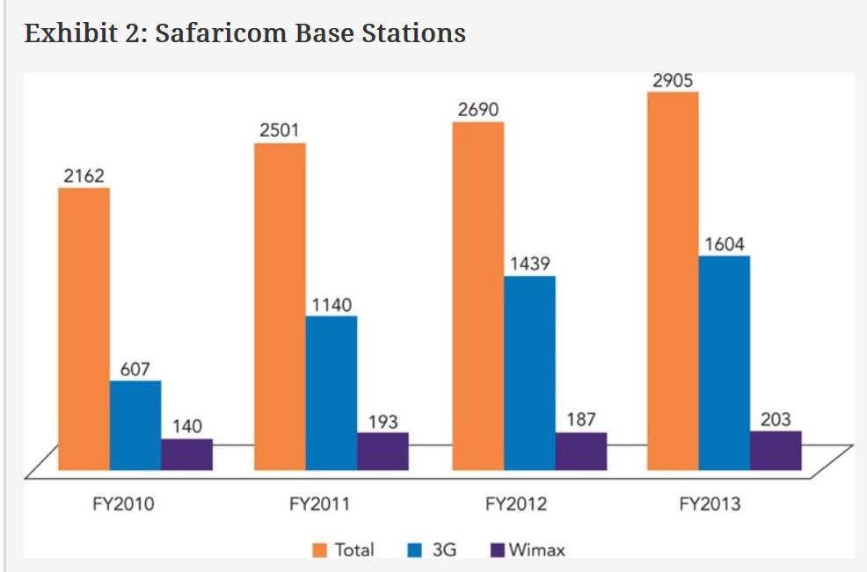
Source: Safaricom Limited. 2013. Annual report. Nairobi, Kenya: Safaricom Limited
In the voice segment, the largest revenue segment for the company, Safaricom offers a wide range of pricing plans, which are often bundled with other services such as data. Services include: Okoa Jahazi, an emergency credit based top-up service; Bonga, a customer loyalty rewards program; Skiza, a call ring-back service; Contacts, a backup service; and premium services including ring tones, wall paper, music, and games.
Within the data segment, Safaricom offers high-speed data for access to email and internet through fixed and mobile broadband. It also offers Sambaza Internet, which allows customers to transfer data airtime to another subscriber. Another program, Night Shift, gives customers cheaper data bundles at night. This incentivized better network utilization during off-peak hours.
Through the Enterprise Business Unit Safaricom provides businesses with data service and dedicated solutions for data storage, hosting, and security problems. In the messaging segment, Safaricom offers customers a wide variety of bundles for SMS, MMS, and video messaging.
Safaricom provides a competitive platform called AppStar for application developers to showcase and be recognized for new mobile applications. The company also introduced new services such as m-agriculture, which gives tips to farmers, m-health, which connects Safaricom customers to medical professionals via SMS to give advice on health issues, and e-learning, which allows mobile access to educational resources for Safaricom customers.²²
M-PESA, Safaricom’s money transfer service, has over 17 million customers and is available in over 65,000 agent outlets, which include supermarkets, gas stations, selected banks, and other authorized Safaricom retailers, and over 2,000 payment partners which include registered businesses that accept M-PESA payments.²³ M-PESA is a fast and affordable way to send and receive money via mobile devices. The service provides many Kenyans access to financial services that they would not normally have. In 2013, Safaricom launched M-Shwari through a partnership with the Commercial Bank of Africa. Customers can transfer funds from M-PESA to M-Shwari, allowing them to save money, earn interest, and even borrow small amounts of money through a “microloans” program. Customers can save as little as 1 Ksh ($0.012 USD) and borrow as little as Ksh 100 ($ 1.22 USD). There are no application forms, no ledger limits, no limits on the frequency of withdrawal, no minimum operating balances, and no charges for moving funds from M-PESA to M-Shwari and vice versa.²⁴
Safaricom has partnered with the Commercial Bank of Africa in order to add innovative solutions to the M-PESA service with M-Shwari. The Commercial Bank of Africa is the largest privately-owned bank in Kenya. It is one of 43 licensed commercial banks operating in the country.²⁵ The Commercial Bank of Africa has operations in both Kenya and Tanzania, where the bank was originally founded. It has only been during the last few years that Safaricom’s competition has followed suit by providing mobile banking services in Kenya.²⁶ Safaricom will also continue to expand its M-PESA service and increase financial inclusion for Kenyans by expanding the distribution network, reducing system downtime, and ensuring geographic redundancy.²⁷

Financial Performance
Financially, the firm is performing quite well. Total revenue increased from 107 billion Kshs in fiscal year 2012 to 124.28 billion Kshs in fiscal year 2013. Revenue within the firm is broken into seven categories in two major segments, service revenue and other revenues. Service revenue includes Voice, Messaging, Mobile Data, Fixed Service, and M-PESA. Other revenue includes Handset, Acquisition, and Other Revenue. A breakdown of these revenues for fiscal year 2012 and fiscal year 2013 is shown in Exhibit 3. Voice services provide the greatest percentage of revenue, followed by M-PESA revenue. In Handset revenue, smart phones currently account for 51% of product revenues, while standard cell phones account for only 32% of product revenue, shown in Exhibit 4.²⁸ 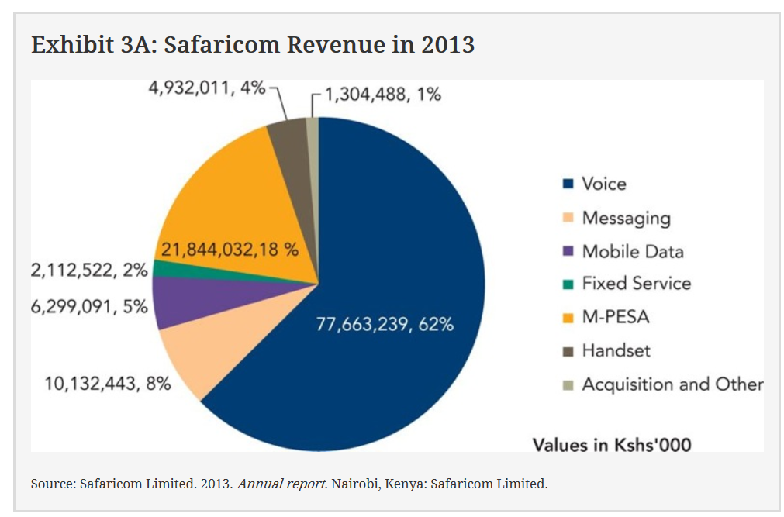

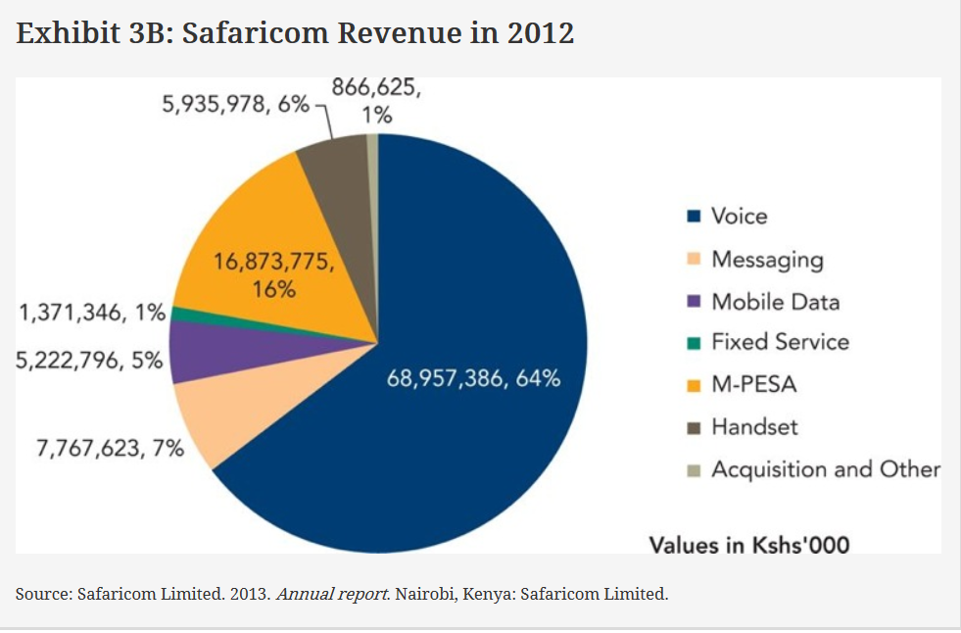

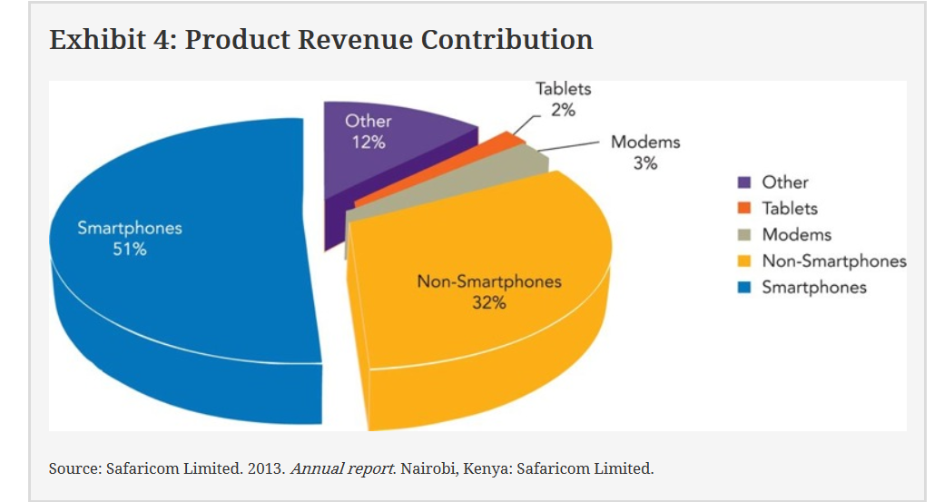
In addition to increasing revenue, Safaricom was able to decrease operating costs from 24% of total revenue to only 23% of total revenue during that same timeframe. These costs savings initiatives are focused in the areas of transmission, inventory, network operating costs (including fuel), and IT costs. Total capital expenditures amounted to 24.88 billion Kshs in FY 2013, of which 90% went to improvements in network quality, capacity, and coverage. Net income increased from 12.63 billion Kshs to 17.54 billion Kshs. Earnings per share increased from 0.32 in FY 2012 to 0.44 Kshs in FY 2013. Free cash flow saw a 55% improvement from 9.35 billion Kshs in FY 2012 to 14.51 billion Kshs in 2013. Safaricom’s dividend policy pays out 85.5% of free cash flow in dividends. Pending shareholder approval, the total dividend for FY 2013 will be 12.4 billion Kshs, the largest dividend in Kenyan corporate history.²⁹ Financial statements are prepared according to the International Financial Reporting Standards and are shown in Exhibits 5 through 7.

Exhibit 5: Consolidated Statement of Comprehensive Income
 | Year ended 31 March
 | 2013 Kshs’000 | 2012 Kshs’000 | 2011 Kshs’000
Revenue | 124,287,856 | 106,995,529 | 94,832,227
Cost of sales | (56,544,436) | (54,139,219) | (45,794,536)
Gross profit | 67,743,420 | 52,856,310 | 49,037,691
Other income | 197,888 | 487,881 | 36,368
Distribution cost | (4,680,665) | (3,544,561) | (3,896,176)
Administrative expenses | (8,440,194) | (7,652,870) | (6,850,839)
Other expenses | (27,720,255) | (21,995,403) | (18,936,895)
Operating profit | 27,100,194 | 20,151,357 | 19,390,149
Finance income | 1,199,298 | 873,518 | 871,249
Finance costs | (2,839,249) | (3,656,280) | (1,907,783)
Share of (loss)/profit of Associate | (9,678) | 805 | 7,748
Profit before income tax | 25,450,565 | 17,369,400 | 18,361,363
Income tax expense | (7,910,755) | (4,741,793) | (5,202,390)
Profit for the year (of which Kshs 17,320,185,000 (2012: Kshs 12,873,482,000) has been dealt with in the accounts of the Company) | 17,539,810 | 12,627,607 | 13,158,973
Other comprehensive income for the year, net of tax | – | – | –
Total comprehensive income for the year | 17,539,810 | 12,627,607 | 13,158,973
Attributable to:
Owners of the Company | 17,539,810 | 12,737,837 | 13,311,587
Non-controlling interest | – | (110,230) | (152,614)
 | 17,539,810 | 12,627,607 | 13,158,973
Earnings per share for profit attributable to the equity holders of the Company
Basic and diluted (Kshs per share) | 0.44 | 0.32 | 0.33
Source: Safaricom Limited. 2013. Annual report. Nairobi, Kenya: Safaricom Limited.

Exhibit 6: Consolidated Statement of Financial Position
 | Year ended 31 March
 | 2013 Kshs’000 | 2012 Kshs’000 | 2011 Kshs’000
Capital and reserves attributable to the Company’s equity holders
Share capital | 2,000,000 | 2,000,000 | 2,000,000
Share premium | 1,850,000 | 1,850,000 | 1,850,000
Retained earnings | 64,015,128 | 59,940,584 | 56,002,747
Proposed dividend | 12,400,000 | 8,800,000 | 8,000,000
Attributable to owners of the Company | 80,265,128 | 72,590,584 | 67,852,747
Non-controling interest | – | (508,886) | (398,656)
Total equity | 80,265,128 | 72,081,698 | 67,454,091
Non-current liabilities Borrowings | 12,000,000 | 12,104,554 | 12,104,932
Payables and acctued expenses | – | 97,525 | 178,013
Total non-current liabilities | 12,000,000 | 12,202,079 | 12,282,945
Total equity and non-current liabilities | 92,265,128 | 84,283,777 | 79,737,036
Non-current assets
Property, plant, and equipment | 95,296,398 | 91,659,218 | 83,022,590
Intangible assets – Licences | 1,422,011 | 2,094,951 | 2,722,706
Intangible assets – Goodwill | 219,151 | 219,151 | 219,151
Investment in associate | – | 9,678 | 8,873
Indefeasible right of use | 4,006,681 | 4,240,400 | 3,756,343
Deferred income tax | 2,553,665 | 2,480,063 | 2,421,142
Prepaid operating lease rentals | 2,227 | 2,021 | 2,661
 | 103,500,133 | 100,705,482 | 92,153,466
Current assets
Inventories | 2,234,294 | 2,653,125 | 5,880,837
Receivables and prepayments | 8,124,808 | 8,190,298 | 9,440,461
Derivative financial instruments | – | – | 111,382
Current income tax | – | 1,542,714 | 1,009,581
Cash and cash equivalents | 14,996,922 | 8,808,058 | 5,259,035
 | 25,356,024 | 21,194,195 | 21,701,296
Current liabilities
Payables and accrued expenses | 27,825,322 | 30,463,358 | 31,101,667
Current income tax | 537,749 | – | –
Derivative financial instruments | – | 147,000 | –
Borrowings | 8,227,958 | 7,005,542 | 3,016,059
 | 36,591,029 | 37,615,900 | 34,117,726
Net current liabilities | (11,235,005) | (16,421,705) | (12,416,430)
 | 92,265,128 | 84,283,777 | 79,737,036
Note: These numbers may vary slightly from company-reported numbers due to differences in accounting conventions
Source: Safaricom Limited. 2013. Annual report. Nairobi, Kenya: Safaricom Limited.

Exhibit 7: Consolidated Statement of Cash Flows
 | Year ended 31 March
 | 2013 Kshs’000 | 2012 Kshs’000 | 2011 Kshs’000
Cash flows from operating activities
Cash generated from operations | 46,486,321 | 40,038,720 | 38,268,803
Interest received | 740,395 | 427,402 | 293,516
Interest paid | (2,192,078) | (1,896,201) | (1,363,200)
Income tax paid | (5,903,893) | (5,333,847) | (6,197,250)
Net cash generated from operating activities | 39,130,745 | 33,236,074 | 31,001,872
Cash flows from investing activities
Acquisition of IGO Wireless Limited, net of cash acquired | – | – | (494,094)
Acquisition of Instaconnect Limited, net of cash acquired | – | – | (2,095)
Purchase of property, plant and equipment | (24,875,965) | (25,278,428) | (25,482,597)
Acquisition of One Communications Limited | (556,380) | – | –
Additions of property, plant, and equipment - IGO Wireless Limited | – | – | (11,608)
Purchase of intangible assets | – | – | (1,600)
Investment in indefeasible rights of use | – | (419,158) | (913,214)
Proceeds from disposal of property, plant and equipment | 71,041 | 16,048 | 17,590
Net cash used in investing activities | (25,361,304) | (25,681,538) | (26,847,618)
Cash flows from financing activities
Proceeds from long-term borrowings | 4,227,958 | 6,392,231 | 7,496,030
Repayments on long-term borrowings | (3,008,535) | (2,399,755) | (9,112,653)
Dividends paid | (8,800,000) | (8,000,000) | (8,000,000)
Net cash used in financing activities | (7,580,577) | (4,007,524) | (9,616,623)
Net increase in cash and cash equivalents | 6,188,864 | 3,547,012 | (5,462,369)
Movement in cash and cash equivalents
At start of year | 8,808,058 | 5,261,046 | 10,723,415
Increase | 6,188,864 | 3,547,012 | (5,462,369)
At end of year | 14,996,922 | 8,808,058 | 5,261,046
Source: Safaricom Limited. 2013. Annual report. Nairobi, Kenya: Safaricom Limited.

Inside Safaricom

Management
Most of Safaricom’s senior management team has vast experience in telecommunications. Leading the team is Robert (Bob) Collymore, who took on the responsibilities of CEO in November of 2010. Bob Collymore replaced Michael Joseph, who had held the position since 2000.³⁰ The transition was amicable as Michael Joseph was heading to retirement and wanted to wait until “a successor is in place”.³¹ Collymore is also the Executive Director on Safaricom’s board of directors, leading with twenty-five years of commercial work experience in the telecommunications sector. Collymore is supported by CFO John Tombleson, who joined the company in November 2011 and has a strong background in financing growth. Prior to Tombleson’s arrival at Safaricom, he held executive positions at Vodafone Qatar, which captured 48% market share within two years of its founding. Biographic information for the senior management team and top members of the board of directors is shown in Exhibits 8 and 9.

Exhibit 8: Safaricom Senior Management Team
Robert Collymore – Chief Executive Officer and Executive Director
Robert (Bob) Collymore, who took on the responsibilities of CEO in November of 2010. He is also the Executive Director on Safaricom’s board of directors leading with 25 years of commercial work experience in the telecommunications sector. Collymore is also a trustee for M-PESA in both Kenya and Tanzania.
John Tombleson – CFO
John Tombleson joined Safaricom as CFO in November 2011 from Vodafone Qatar and has a background in financing growth. Tombleson first joined Vodafone in New Zealand in 2003. After two years of being founded they captured 48% market share. Tombleson also resides on the board of directors as the CFO.
Joseph Ogutu – Director Strategy & Innovation
Starting in October 2012 Joseph Ogutu was appointed as the Director, Strategy & innovation. In his role Ogutu develops Safaricom’s position in the industry by formulating strategic direction and driving innovation in their products and services. Mr. Ogutu also has 25 years of experience in telecommunications and severs as the chairman of Safaricom Foundation.
Rita Okuthe – Director, Marketing
Rita Okuthe joined Safaricom in August 2009 as the Head of Consumer Segments and then was appointed as the Director, Marketing in May 2013. Okuthe has a Master’s degree in Marketing and is known to drive revenues by having a great understanding of consumer behaviors.
Sylvia Mulinge – General Manager Enterprise Business Unit
With over a decade of marketing experience, half of which was in the telecommunications industry, Sylvia Mulinge joined Safaricom as the General Manager Enterprise Business Unit in February of 2006. Coming from Unilever she and has a honed skill in consumer marketing and brand activation.
Betty Mwangi – General Manager, Financial Services
Betty Mwangi-Thuo was appointed General Manager of Financial Services in March 2011. She has over 13 years of experience in the telecommunications industry and manages the business unit that includes M-PESA. Mwangi was recognized by MCI in June 2010 as one of the top 10 women in mobile globally.

Exhibit 9: Safaricom Board of Directors
Nicholas Nganga – Chairman
Nicholas Nganga joined Safaricom’s board of directors in May 2004 and was elected the chairman January 2007. Mr. Nganga also holds positions at G4S Security (chairman) and the University of Nairobi (Vice-chair of the Council).
Michael Joseph – Non-Executive Director
Michael Joseph was the previous CEO of Safaricom and has extensive international experience in the implementation and operation of large wireless and wire line networks. Mr. Joseph was elected to the board in September 2008, and has been a recipient of the CEO of the Year award.
Robert Collymore – Executive Director
Bob Collymore is the current CEO of Safaricom and has more than 25 years of commercial experience working in the telecommunications sector. Collymore is also a trustee for M-PESA in both Kenya and Tanzania.
John Tombleson - CFO
John Tombleson joined Safaricom as CFO in November 2011 from Vodafone Qatar and has a background in financing growth. Tombleson first joined Vodafone in New Zealand in 2003.
Susan Mudhune – Non-Executive Director
Susan Mudhune is the former chairman of Kenya Commercial Bank and joined the Safaricom board in May 2009. She also holds the position of Director at Kenya Commercial Bank.
Nicholas Jonathan Read – Non-Executive Director
Nick Read joined Vodafone in 2001 and is responsible for operations in Africa, Middle East, and Asia Pacific. Read joined the Safaricom board in January 2010.
Ahmed Essam – Non Executive Director
Ahmed Essam joined Vodafone Egypt in 1999 and now is responsible for the commercial operations in Africa, Middle East and Asia Pacific. Essam joined the board in September 2012.
Sunil Sood – Non Executive Director
Sunil Sood is the COO for Vodafone India and joined the Safaricom board in September 2012. Sood has a diverse background and was originally the CEO of Pepsi in Bangladesh, until building 12 years of telecom experience with Vodafone.

Training
Safaricom’s experienced management team has worked to share its expertise with the entire organization. The Subject Matter Expert Program has been set up with 50 staff members in various disciplines who teach technology, finance, team building, and soft skills to other members in the organization. The goal is to ensure a high customer experience at all points of contact with the customer by providing employees with world-class programs and exposure to new technologies, professional development, and service offerings. In addition to internal training and professional growth opportunities, Safaricom expanded their Graduate Management Program in the second quarter of 2013. This program takes employees with high potential through a university program that equips them with functional and business skills. This year 25 employees are expected to complete this program.³²

Human Resources
Safaricom directly employs 3,254 people in the ranks of management and strives to promote from within the organization. Some of its key hiring practices include filling open positions 50% of the time with internal employees and hiring equal numbers of men and women. Safaricom has achieved female representation in 30% of G4 management level positions and above. A breakdown of the company’s employment and headcount statistics is shown in Exhibit 10. A survey was recently completed to measure overall employee satisfaction and manager engagement. Both metrics have improved by over 10% since the inception of the program, which shows management’s commitment to improving the working environment within the organization.³³

Exhibit 10: Headcount Statistics
Job Level | Total Staff ‘12^{i} | Women ‘12^{i} | Total Staff ‘13^{ii} | Women ‘13^{ii} | % Women ‘12^{i} | % Women ‘13^{ii}
1 | 1 | 0 | 1 | 0 | 0.00% | 0.00%
2 | 10 | 3 | 11 | 4 | 30.00% | 36.36%
3 | 34 | 14 | 36 | 15 | 41.18% | 41.67%
4 | 126 | 33 | 142 | 41 | 26.19% | 28.87%
5 | 220 | 66 | 259 | 67 | 30.00% | 25.87%
6 | 516 | 181 | 548 | 210 | 35.08% | 38.32%
7 | 545 | 238 | 572 | 249 | 43.67% | 43.53%
8 | 1247 | 623 | 1095 | 560 | 49.96% | 51.14%
9 | 2 | 0 | 2 | 0 | 0.00% | 0.00%
Temp | n/a | n/a | 588 | 364 | n/a | 61.90%
Total | 2701 | 1158 | 3254 | 1510 | 42.87% | 46.40%
^{i}
Source: Safaricom Limited. 2012. Annual report. Nairobi, Kenya: Safaricom Limited.
^{ii}
Source: Safaricom Limited. 2013. Annual report. Nairobi, Kenya: Safaricom Limited.

Distribution Channel
Safaricom manages a direct dealership network of 2,600 locations, which directly or indirectly employs over 22,000 people. Furthermore, there are over 250,000 retail outlets in Kenya that offer Safaricom products. To help stimulate the growth of these dealers, Safaricom has rolled out several initiatives to incentivize increased sales. These include training on data and data related products, offering short-term credit to ensure airtime can be sold at peak times (holidays or special events), introduction of an 8% commission on data used on lines sold by the specific dealer, and financial support on distribution tools such as motorbikes, used for advertising and promotion.

Sales and Advertising
In 2010 Safaricom sacrificed some operating profits by increasing sales and advertising expenses by 16.3% from fiscal year 2009 levels. This was a conscious decision made by the senior management team as they sought to reach and educate their diverse market. In 2011, to expand their marketing efforts, Safaricom focused on understanding the voice of the customer, improving the way the company communicates its messages, and aiming to become more intimately involved within the community. The “Niko na Safaricom” campaign was launched in November 2010 and gained traction in 2011. The campaign’s goal is to stimulate customer loyalty and to reduce customer turnover. This campaign fortified the Safaricom brand by communicating a commitment to Kenya and its people, reminding the public they are a successful Kenyan company built and made up of the people of Kenya. Motivation segmentation took center stage as Safaricom strived to understand differing segments of their target market in hopes to align product development, communication, resources, and distribution strategies to meet diverse needs. In 2012, Safaricom was voted the most valuable brand in Kenya. As marketing activities continued to expand, 2013 saw the consolidation of all marketing functions across Safaricom, centralized into a single division led by Rita Okuthe, who was appointed Marketing Director in May 2013. Under her leadership the “Naweza” campaign was launched. This campaign was to further weave the Safaricom brand into the Kenyan culture. Safaricom now sponsors the largest sporting event in Kenya (seven-a-side rugby) called Safaricom Sevens, and launched Niko Na Safaricom Live to give local music talent the chance to perform on a world class platform.³⁴

Strategic Priorities
Safaricom has identified its intent to transform the lives of its customers, shareholders, business partners, staff, and the communities Safaricom serves. The company has defined the following strategic priorities:
- 1. Deliver the ‘Best Network in Kenya’
- 2. Grow mobile and fixed data
- 3. Deepen financial inclusion
- 4. Retain and reward the loyal customer base
- 5. Encourage further innovation.³⁵
Under its “Best Network in Kenya” initiative, Safaricom has worked to increase 2G and 3G coverage, modernize the network in six key cities, roll-out fiber in 40% of sites in Nairobi, increase speeds, deliver value-based pricing, lower the pricing of 3G smartphones, and improve customer services. Other actions include: upgrading old cell sites, reducing the number of dropped calls, decreasing network downtime, and broadening the reach of their telecom services. Although improvements in network quality are a tremendous opportunity, there is some risk, including the risk of vandalism leading to service disruption, general security, especially in northeastern Kenya, energy availability and reliability, and M-PESA service delays. The instability of the Kenyan national energy grid and lack of energy grid availability in some rural or isolated parts of the country limits growth.³⁶

The Safaricom Foundation
The Safaricom Foundation was founded in 2003 and disbursed 416.8 Ksh million to 119 projects in 2012. The foundation is divided into ten areas, including Education, Health Education, Disaster Relief, Water, Economic Empowerment, Sport, Environment, World of Difference, M-PESA Foundation, and Other.³⁷ Safaricom recognizes “the continued need to invest in maternal and child health; as well as the important role that mobile communications technology plays in transforming lives in areas such as health, education, and economic empowerment.”³⁸ The Safaricom Foundation’s “World of Difference” program is a multi-phase initiative that empowers the citizens of Kenya to make a difference in the areas of health, education, economics, access to clean water, disaster relief, environmental conservation, arts, culture, and sports.³⁹

Vodafone Group PLC
Vodafone Kenya Ltd., whose parent corporation is Vodafone Group Plc, is the largest shareholder in Safaricom Limited.⁴⁰ Vodafone has over 404 million customers, with 68% of these customers located in emerging markets.⁴¹
The company has operations in every continent except Antarctica. In Africa and the Middle East, Vodafone operates in nine countries including: Qatar, Egypt, Kenya, Democratic Republic of the Congo, Ghana, Tanzania, Mozambique, Lesotho, and South Africa.⁴² According a study by the World Bank, a 10% increase in mobile penetration can add 1.2% to the annual economic growth in a developing nation. The company’s vision is for Vodafone mobile services to further improve people’s livelihoods and the quality of life.
Vodafone licenses (although Safaricom operates) the M-PESA service in Kenya.⁴³ M-PESA is currently also in place in Tanzania, South Africa, Afghanistan, Qatar, and Fiji. Moreover, Vodafone launched M-PESA on a small scale in Rajasthan, India, in preparation for launch across Indias in 2013.⁴⁴ Safaricom has roaming agreements in place with several Vodafone subsidiaries in other countries, which benefits Safaricom customers when they travel. There is an additional agreement in place that gives Safaricom access to Vodafone’s global price book and supply chain resources for the purposes of procurement, terminals management, technical expertise, best practices, business knowledge, business assurance, consumer products, and marketing support. This agreement also stipulates a participation fee, fixed at six million Euros annually.⁴⁵

Industry Competition
Safaricom currently has three direct competitors in Kenya – Bharti airtel, Telkom Kenya, and YuMobile.⁴⁶ There are also several other potential competitors, defined as firms that operate in Africa but not in Kenya, including Millicom, Etisalat Emirate Telecommunications Company, and MTN Group.

Bharti airtel
Bharti Airtel Limited is a leading global telecommunications firm with operations in Africa and Asia. The company is headquartered in New Delhi, India and has 190 million mobile subscribers in India alone, with an additional 72 million mobile customers internationally.⁴⁷ The firm describes itself as a multi-platform service firm operating in telecom, enterprise, and digital television, unified under the “airtel” brand.⁴⁸ In terms of subscribers, it ranks in the top four for global mobile service providers. Under IFRS standards, the firm’s revenue was Rs. 202,995 million and EBITDA was Rs. 65,449 million.⁴⁹ This amounts to revenue of $14.7 billion USD and EBITDA of $4.3 billion USD. Of this revenue, 49% can be attributed to Indian and South Asian wireless services and 27% comes from African wireless services. Bharti airtel has the greatest market share in India, holding 22% of the wireless subscriber market. Vodafone is in second place with a 17% market share. In 2011, Bharti airtel acquired Zain Africa B.V., gaining entry to the continent. The firm now operates in 20 countries with the objectives of growing the brand, diversifying to reduce its India risk, and replicating its effective operations model. Bharti believes it has achieved a global stature with a focus on emerging markets, significant synergies and a strong platform for future expansion.⁵⁰
Bharti airtel operates under its unique business model known as the “Minutes Factory”, which focuses on producing the lowest cost minutes while maintaining/growing margins. This strategy focuses on driving affordability to gain more users and thus more usage, which leads to improved economies of scale and an increase in profitability, thereby also allowing the firm to make the product more affordable.⁵¹

Telkom Kenya (Orange)
Telkom Kenya was established in 1999 as Kenya’s original telecommunications operator.⁵² The firm’s mission states, “We will connect every Kenyan through integrated communication solutions that simplify and enrich their lives. We are a social and business catalyst, liberating and inspiring people with ideas and services to connect, collaborate, and co-create in new and exciting ways”.⁵³ Their values are: friendly, straightforward, honest, refreshing and dynamic.⁵⁴ Telkom Kenya provides integrated communications solutions in Kenya with a wide range of voice and data services as well as network facilities for residential and business customers. The company has 2.8 million subscribers on various wireless platforms throughout Kenya.⁵⁵ Furthermore, the firm reinvests profits to promote corporate social responsibility, which includes a commitment to sustainable development achieved through Telkom Kenya’s three chief focus areas: health, environment, and digital solidarity, spreading the benefits of mobile technology and the internet to enable more people to communicate, learn, and share knowledge.⁵⁶
In 2008, Telkom Kenya formed a partnership with Orange Group (formerly France Telecom) to launch the Orange brand in Kenya.⁵⁷ Telkom Kenya operates prepaid and postpaid mobile services through the Orange Brand, provides Internet through 3G services, and offers fixed landline voice and internet services for homes and business. The company also offers Orange Money, which competes directly with Safaricom’s M-PESA.⁵⁸ The firm is not publically traded; no financial information is available.

Essar Telekom Kenya (yuMobile)
The Essar Group is a multinational firm based in India, with operations in a variety of industries including steel, oil and gas, power, telecom services, shipping, ports, and other projects. Essar Group employs 75,000 people, operates in 25 countries and has revenues of over $27 billion USD. Essar Telekom Kenya operates in Kenya under the brand “yuMobile”, which launched in December 2008. The company was able to achieve countrywide coverage in only ten months, and currently has three million subscribers.⁵⁹ In August 2012 Essar Group confirmed its plans to exit the mobile market in Kenya by selling its 72% stake in yuMobile due to a tough operating environment and a negative earnings trend. This move may be linked to Essar’s strategic move to hedge risk in the increasingly competitive telecom sector.⁶⁰ So far no one has acquired the yuMobile brand from Essar. yuMobile provides value added services such as yuRadio, yuRoaming, yuCredo, an emergency airtime credit service, various bundles available for SMS, MMS, Data, and yuCash, a mobile money transfer service.⁶¹ The firm is not publically traded.

Millicom
Millicom offers digital products and services to emerging markets in Latin America and Africa through its brand “Tigo”⁶². The origins of the firm began in 1979, but it was in 1990 that the organization Millicom International Cellular was formed from the merger of Kinnevik and Millicom Inc. The company ran into financial trouble in 2002 and it had to restructure its balance sheet. The Tigo brand was launched in Latin America in 2004, followed shortly by the brand’s launch in Africa.⁶³ Revenue in 2012 was $4,814 million USD, with net profit of $508 million USD. The firm is fueled by an ethos of “demand more”, stating that “the markets we are creating are themselves demanding more of us and we must respond.” Additionally, Millicom wants to “transform Tigo from a telecommunications operator to a digital lifestyle brand by becoming an integral part of our customers’ everyday lives.”⁶⁴ Millicom operates in four core areas: mobile, cable, mobile financial services, and commerce and services. Of particular interest is Millicom’s mobile financial service, which operates in Latin America and Africa, where the vast majority of the population lacks access to banking services. The firm has 47 million mobile customers across three regions. Operations in Africa account for $974 million USD in revenue, $359 USD in EBITDA, and 18.9 million customers. The company operates in the Democratic Republic of Congo, Tanzania, Chad, Mauritius, Rwanda, Senegal, and Ghana.⁶⁵

Etisalat Emirate Telecommunications Company
Etisalat Emirate Telecommunications Company (Etisalat) is a leading telecommunications operator in the Middle East and Africa, with global headquarters located in the United Arab Emirates. The firm has operations in 15 different countries, including five countries in Africa: Tanzania, Sudan, West Africa, Egypt, and Nigeria. In Tanzania, the firm operates under the brand name Zantel, an abbreviation for Zanzibar Telecom Limited. In Sudan, the firm operates as Canar and commands a 61.5% market share. Atlantique Telecom is a subsidiary of Etisalat in Western Africa, operating under the brand name MOOV, with operations in the Ivory Coast, Benin, Gabon, Togo, and Central Africa. In Egypt, the company operates as Etisalat Misr and covers 98% of the country. Finally, Etisalat Nigeria, launched in 2007, has over two million subscribers already.⁶⁶ Nigeria is the continent’s biggest mobile market with over 90 million subscribers. The company operates a service called Easy Wallet, which allows customers to transfer money using their mobile devices. Overall, the company has 139 million subscribers, and in 2012 generated 32.9 billion United Arab Emirate Dirham (AED) in revenue and 6.7 billion AED in profit.⁶⁷

MTN Group
MTN Group Ltd. was formed in South Africa in 1994 and maintains its headquarters in Johannesburg. The group now does business in 21 countries in Africa and the Middle East including: Afghanistan, Benin, Botswana, Cameroon, Congo Brazzaville, Cote D’Ivoire, Cyprus, Ghana, Guinea-Bissau, Guinea Conakry, Iran, Liberia, Nigeria, Rwanda, South Africa, Sudan, Swaziland, Syria, Uganda, Yemen, and Zambia. In 2013, the company had 201 million subscribers. MTN Group has over 34,000 employees who speak five different languages and represent 55 nationalities. Services include 2G and 3G voice networks, including prepaid and postpaid airtime, international roaming, SMS, MMS, and internet access via various platforms, including MTN MobileMoney.⁶⁸ In 2011, MTN launched the first 4G (LTE) network pilot in South Africa. In 2012, MTN became the first African brand represented in the BrandZ Top 100.⁶⁹ The firm’s vision is to be the “leading telecommunications provider in emerging markets”.⁷⁰ In 2012, the company had revenues of R135.1 billion and net income of R10.498 billion.⁷¹

Next Moves
With the turnaround in the Kenyan economy, Safaricom is poised to continue to grow in both revenues and profits. How should Safaricom maximize growth, increase profitability, and maintain or expand their market share? Is the firm’s recent announcement to start providing television services a good move, or will this diversification outside of its core business hurt Safaricom in the long-run? Should Safaricom differentiate its banking services from those of its competitors? Safaricom originally differentiated its service by providing access to banking functions through its mobile platform; however, the company’s top competitors have started services that mimic Safaricom’s mobile banking services such as YuCash and Airtel Money.⁷² How can it stay ahead of the competition? Should Safaricom look to grow through acquisitions? Is geographic expansion outside of Kenya the best way to grow? If so, to which nations should they expand and how? The internet is a wonderful tool for linking people together. Is investment in 4G LTE technologies a good option for Safaricom? How can Safaricom take maximum advantage of its relationship with Vodafone? These are difficult questions to answer, but questions the board of directors will need to carefully consider if they want Safaricom to continue to prosper in the growing and dynamic telecommunications market in Africa.

